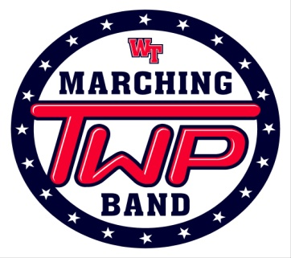
Minuteman News
Hello Parents, Guardians and Fans of the Washington Township Marching Band!!!! The season is going by quickly as we are already into October! We have gotten a lot of positive reviews from both people in the Community as well as people in the marching band world. We need to continue working hard to achieve more and put out the best performances possible.

Information for this week’s Performance/Rehearsal!!!
- Back To School Night
THURSDAY October 5, 2017
From what I have been told in the past rehearsal for Back To School night is usually extended due to the number of people that are at Back To School Night. We are going to turn this into a performance opportunity.

We would like to invite all Parents out to the Stadium at 9:30pm to watch a full run of the show.
Rehearsal will end at 9:45pm on Thursday.

- There is NO GAME this week. Please enjoy your Friday Night.

- Competition is at Clearview Regional High School this week.

Report Time is 11:00am. Please eat before you attend.
Load at approximately 2:00pm
Leave approximate 5:30pm
Return to the High School at approximately 10:45 – 11:00pm.

I am aware that there are SAT’s on this day. If your child is planning on taking the SAT’s on Saturday, please tell them to make sure I know before Saturday.

This is an extremely important show for us. The next couple of performances are going to set us up for placement going into the Region Championships as well as the Atlantic Coast Championships.

- Thank you to the Parents that have come out to help!!!!

Here is a special thank you to those parents that have stepped up and donated their time and energy to help the marching band throughout our season.
AGAIN YOU ARE A HUGE PART OF OUR SUCCESS!!!!
We need your help please!!!! We want and need you!!!! We are need parents to help move props, move equipment, loading the truck and managing our Championship Show on October 22.
AGAIN YOU ARE A HUGE PART OF OUR SUCCESS!!!! If you have any questions, please ask any Executive Board Member or Mr. Spencer.

If you are still not receiving e-mails and or Remind 101 messages please contact us. We want you to be informed but we need to know if you are receiving all of the information that is being posted.

- Payment Schedule for the New Orleans Trip

Here are the dates of the next payments due of the Trip.

September 30 - $300
October 16 - $400
November 1 - $400
November 16 – Balance is due.

If you have any questions you can see Mr. Spencer. Mr. C is helping Mr. Spencer with the trip and is handling the money so if there are any questions you may also ask him.

People are asking about information on the trip. I still do not have a hard count of the students that are attending this trip. We have people who are saying that they are going but have not made a payment yet and people who have decided not to go.

I can’t give you any flight information until we have a hard number and can confirm the flight information. Please make a decision no later than Saturday as to whether or not you are planning on attending this trip.

Thank you for your support!

Township….. Together With Pride!!!!!
Mr. Spencer

